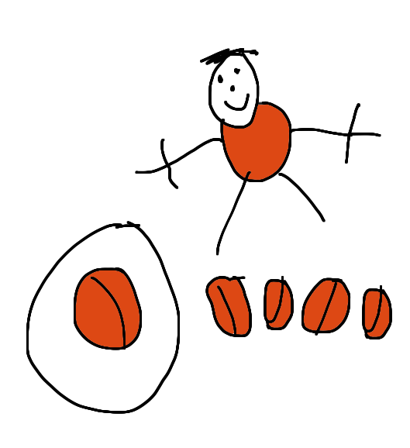
Five Honey Biscuits
Five honey biscuits
With yumminess galore
Mummy ate one
Then there were_____.
Four honey biscuits
Two and two, you see.
Daddy ate one
Then there were _____.
Three honey biscuits
And before I knew
Sister ate one
Then there were _____.
Two honey biscuits
Oh, what fun.
Brother ate one
Then there was_____.
One honey biscuit
I’ll grab it and run.
When I eat it,
There will be ….none!
[Based on Five Sugar Cookies by Jan Warren]

Who stole the cookies from the cookie jar?
Insert family, pet or toy names into this well known American Rhyme
Who stole the cookies from the cookie jar?
Sophy stole the cookies from the cookie jar!
Who me?
Yes you!
Couldn’t have been!
Then who?

Who stole the cookies from the cookie jar?
Timmy stole the cookies from the cookie jar!
Who me?
Yes you!
Couldn’t have been!
Then who?

Who stole the cookies from the cookie jar?
Mummy stole the cookies from the cookie jar!
Who me?
Yes you!
Couldn’t have been!
Then who?

