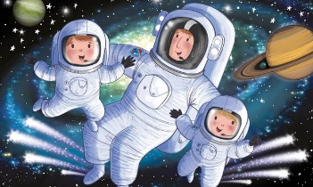
My Space Diary

……………………………………………………………………………………………………………………

……………………………………………………………………………………………………………………

…………………………………………………………………………………………………………………..

…………………………………………………………………………………………………………………

…………………………………………………………………………………………………………………

