Instructions for Queen Gloriana

How to have your own special toy

1.

2.

3.

4.

5.

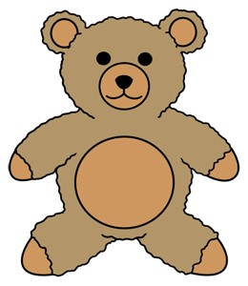

by …………………………………………….

By ……………………………………………………..