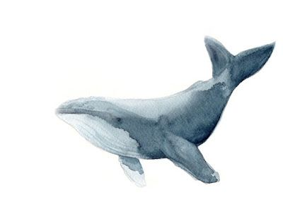
My story about Noi and the whale

……………………………………………………………………………………………………………..

…………………………………………………………………………………………………………….

…………………………………………………………………………………………………………….

…………………………………………………………………………………………………………..

……………………………………………………………………………………………………………

…………………………………………………………………………………………………………..

…………………………………………………………………………………………………………..

……………………………………………………………………………………………………………

...............................................................................................................

by ……………………………………………………….

