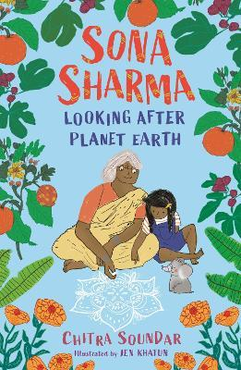

Activity Book

Name ………………………………………………………………………………………..

Sona’s Family
Draw pictures of Sona, her baby sister, her parents and grandparents here.
Add their names and relationship to Sona eg ‘Thatha Sona’s grandfather.’

My Plan to look after Planet Earth

1.

2.

3.

4.

5.

6.

My ideas for Kolam Designs

My Acrostic Poem

Design a Poster
Design a poster to remind your family or friends to
- save energy ( eg by remembering to turn off lights)
or
- reduce plastic use ( eg by using canvas or cloth bags when shopping)

